smart-car
Phase 1: Simulation Scenario Construction
- mvp_road.world: A minimum viable scenario: A car is on a highway, with static obstacles (construction buckets) and dynamic obstacles (blue cylinders representing moving pedestrians) in front of it.
Execute in the terminal：
ros2 launch gazebo_ros gazebo.launch.py world:=mvp_road.world
Load highways and obstacles：
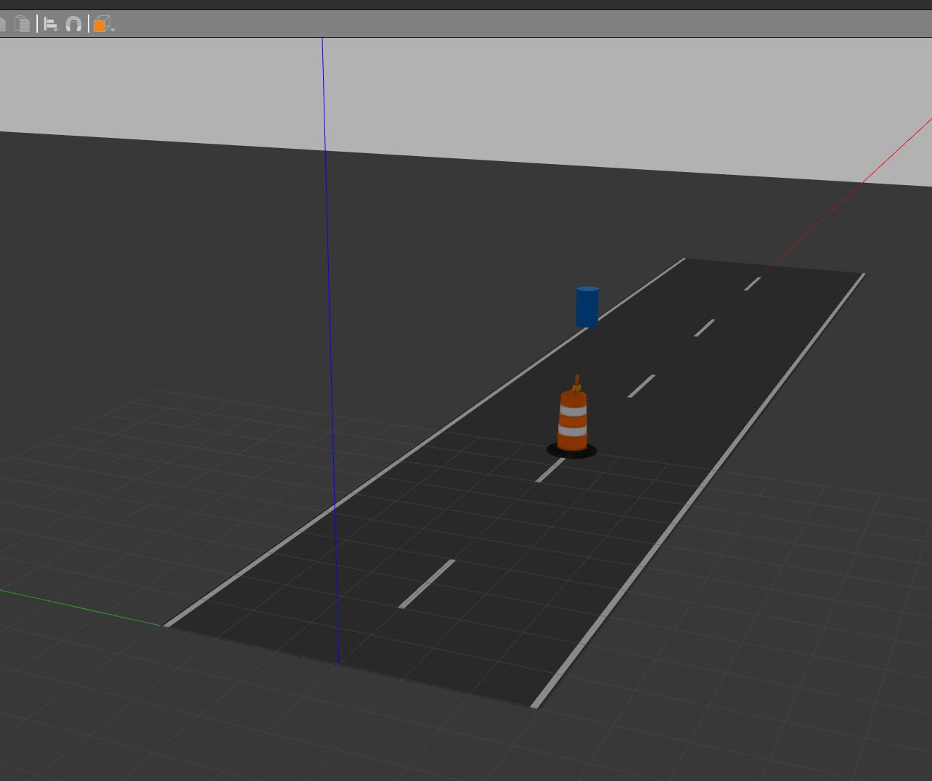

- Load a small car with an RGB color camera
export TURTLEBOT3_MODEL=waffle_pi
ros2 launch turtlebot3_gazebo spawn_turtlebot3.launch.py x_pose:=3.0 y_pose:=0.0 z_pose:=0.05
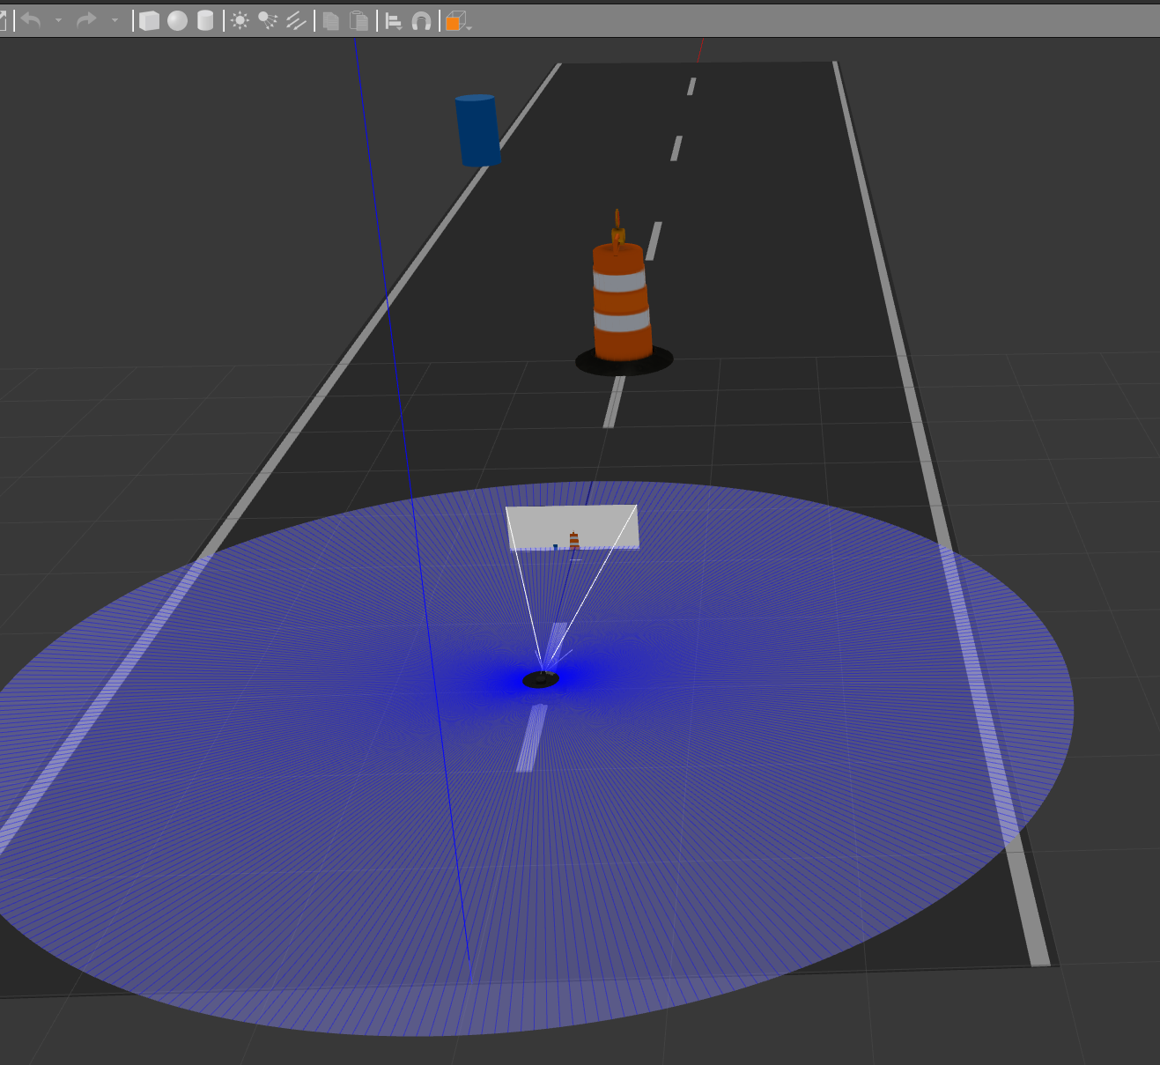

- Get pedestrians moving
python3 move_pedestrian.py
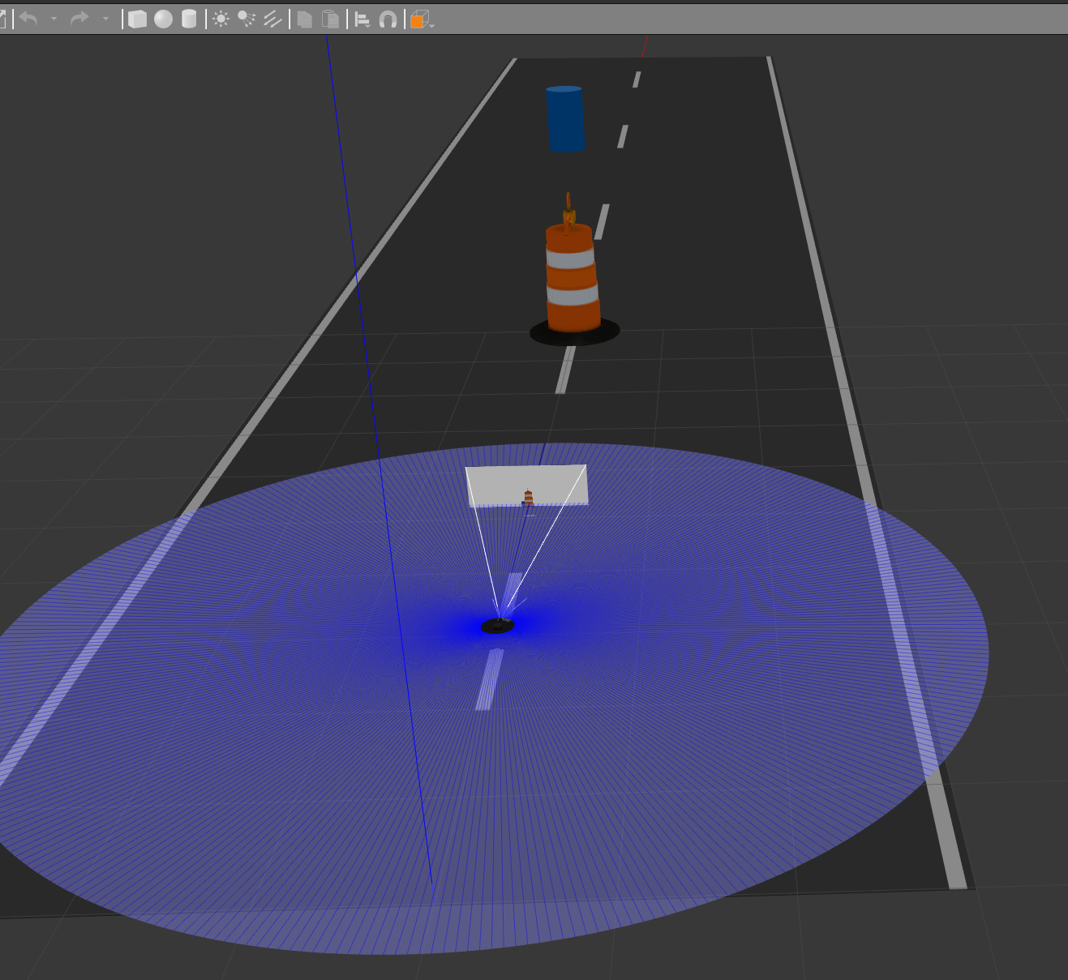

- The grayscale optic nerve is activated to convert the color image into a single-channel grayscale image, which is then compressed to 64×64 for use in subsequent CNN training.
python3 rl_vision.py
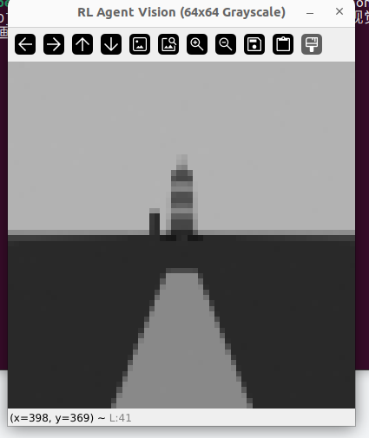

Phase 2: Visual Perception Pipeline (Data Preprocessing)
- Status: In Progress (Parallel Development)
- Objective: Transform raw, high-dimensional simulation data into a lightweight format suitable for reinforcement learning.
- Core Work: We capture the RGB camera feed from the Gazebo simulation, convert it to grayscale to retain lane lines and object contours, and aggressively compress it into a 64×64 matrix. This single-channel matrix becomes the official "State" representation for the RL agent, mimicking a pure-vision autonomous driving approach.

Phase 3: Environment Wrapper & Brain Construction
Status: In Progress (Parallel Development)
- Objective: Build the reinforcement learning framework and the neural network architecture.
- Core Work (Teammate): Develop a PyTorch Convolutional Neural Network (CNN) to ingest the 64×64 matrices and extract a 256-dimensional 1D feature vector.
- Core Work (You): Build a standard Gymnasium (OpenAI Gym) wrapper around the ROS 2 environment. This involves programming the reset(), step(), and compute_reward() functions to define how the car moves and how it is penalized for crashing or rewarded for progressing.

Phase 4: SAC Training & Local Obstacle Avoidance
Status: Up Next
- Objective: Train the agent to navigate the MVP scenario (yielding to pedestrians, nudging around barrels).
- Core Work: Connect the teammate's CNN feature extractor to the Soft Actor-Critic (SAC) algorithm. We will constrain the action space (focusing mostly on longitudinal speed control first) and let the agent learn the optimal braking and steering policies through trial and error in the customized Gazebo track.

Phase 5: System Integration & Global Path Tracking
Status: Future Goal
- Objective: Deploy the trained RL agent as a local planner within a complete autonomous driving stack.
- Core Work: Integrate a traditional global planner (like A* via ROS 2 Nav2) to handle macro-navigation (A to B). The RL agent will no longer wander aimlessly; it will continuously follow a dynamic "lookahead waypoint" provided by the global planner, using its trained pure-vision policy to dodge any dynamic or static obstacles along the way.

